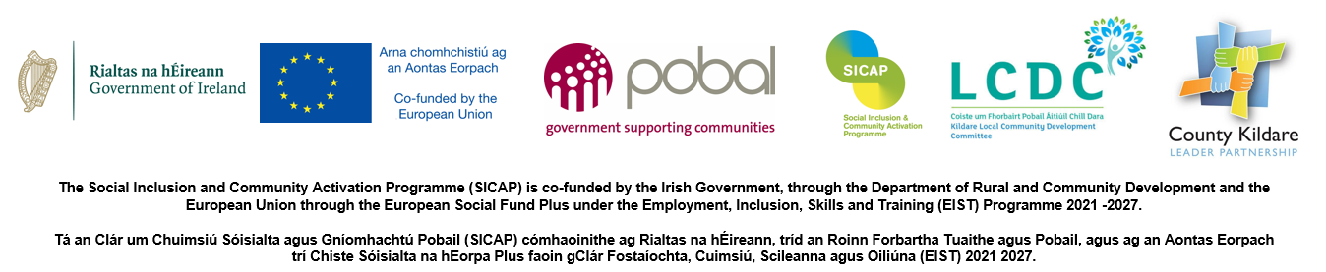
Through the Social Inclusion Community Activation Programme (SICAP), County Kildare LEADER Partnership offers a variety of services to eligible individuals who wish to access training or education, develop or start a business or to local community groups within County Kildare. The programme has a focus on geographically disadvantaged areas & groups working with specific target groups of the programme
Kildare Emerging Social Enterprises Programme 2024
Expression of Interest
County Kildare LEADER Partnership is inviting expressions of interest under the SICAP Programme for Feasibility Assessment and Small Grants for Social Enterprises. This scheme which is funded under the SICAP Programme will provide a feasibility assessment performed by 2into3, and up-front grants of up to €2,500.00 per Social Enterprise for development costs which will enable new and emerging social enterprises to improve their social impact. The feasibility assessment must be completed and approved up-front grant assistance must be spent and receipted by 11th December 2024.
Only social enterprises, as defined in the National Social Enterprise Policy (see below), may apply under this scheme. All applicants will be checked and verified to ensure they meet the definition. Applicants who do not meet this definition will not be considered.
A Social Enterprise is an enterprise whose objective is to achieve a social, societal or environmental impact, rather than maximising profit for its owners or shareholders.
It pursues its objectives by trading on an ongoing basis through the provision of goods and/or services, and by reinvesting surpluses into achieving social objectives.
It is governed in a fully accountable and transparent manner and is independent of the public sector. If dissolved, it should transfer its assets to another organisation with a similar mission.
National Social Enterprise Policy 2019
Expression of Interest should be made directly to County Kildare LEADER Partnership. The completed expression of interest form attached below should be signed and emailed to Aóife Malone aoife@countykildarelp.ie .
The deadline for receipt of EOI is 5pm on Friday 11^{h} October, 2024.
By completing this Expression of Interest Form, you consent to the data on the form being considered to enable a decision to be made on your application.

Applicant Details
Name of Social Enterprise:
Contact Person:
Role of Contact Person:
Contact Correspondence Address (including Eircode):
Contact Email Address:
Contact Correspondence Telephone No.:
Please provide a short description of your organisation (including number of staff) and its current activities below:

Organisation Details
Annual Turnover of organisation:
Tax Clearance Cert Number:

Declaration
A Social Enterprise is an enterprise whose objective is to achieve a social, societal or environmental impact, rather than maximising profit for its owners or shareholders.
It pursues its objectives by trading on an ongoing basis through the provision of goods and/or services, and by reinvesting surpluses into achieving social objectives.
It is governed in a fully accountable and transparent manner and is independent of the public sector. If dissolved, it should transfer its assets to another organisation with a similar mission. (National Social Enterprise Policy for Ireland Definition, 2019)

I confirm that the organisation which I represent-
Is an enterprise whose objective is to achieve a social, societal or environmental impact, rather than maximising profit for its owners or shareholders. | Please tick here to confirm _________
Pursues its objectives by trading on an ongoing basis through the provision of goods and/or services. | Please tick here to confirm _________
Reinvests any surpluses into achieving social objectives | Please tick here to confirm _________
Is governed in a fully accountable and transparent manner and is independent of the public sector. | Please tick here to confirm _________
If dissolved, it will transfer its assets to another organisation with a similar mission. | Please tick here to confirm _________

I declare that the information provided by me on this application form is truthful and complete.
Signed: _________________________________ Date:_________________________
Print Name: ______________________________
Position in Organisation: __________________________________

