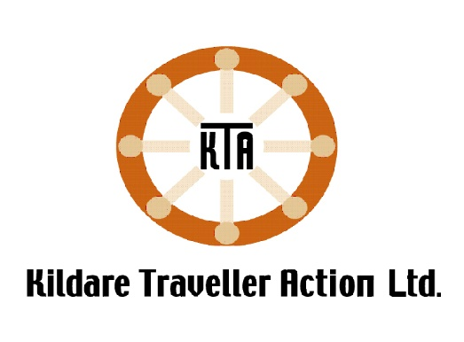

Kildare Traveller Action is seeking a committed person for the post of Community Development Worker for Travellers Men’s Health with the aim of Continuing to enhance the work of the organisation by engaging directly with Traveller men and service providers to address and highlight the health needs and issues in the Community.
The aim of the Post is
- To carry out outreach work with Traveller men in Athy in order to build up trust and relationships.
- Build the capacity of Traveller men to participate in group activities and all areas of health development, particularly in determining their health priorities.
- To establish channels of Communication with all Traveller men throughout Athy and promote engagement and participation.
- To build the capacity of Traveller men in Athy to take more control over their health and gain a greater understanding of the wider determinants of health.
- To represent the issues of Travellers men’s Health on a Range of Forums as relevant.
- To work in partnership with relevant agencies to promote the understanding of factors affecting Traveller Men.
- To work towards a greater inclusion of Traveller Men in Mainstream Services.
Skills Essential to Post
- Qualification in Health / Community Development Related Discipline, And/or training in Community Development or Health
- Experience of delivering health related activities
- Experience of responding to needs of mens group using community development approach
- Experience of working with the Traveller Community especially Traveller Men
- Excellent Communication skills
- Excellent computer skills – Word, Excel and Email
- Ability to identify needs and arrange activities accordingly
- A demonstrable commitment to human rights and social justice and a commitment to work from an anti-racist and equality work perspective;
- Experience of working one to one with clients
- Demonstrated ability to work on own initiative and as part of a team.
- Experience in facilitating group activities for Young People and Adults.
- Access to own transport and hold a full clean driving licence.
Note This position is offered subject to Garda vetting and reference checks

Duties and Responsibilities
Consultation with Traveller Men throughout Athy to identify their needs in relation to Men’s health and wellbeing.
Work with Traveller men in Athy to develop a Traveller Men’s shed programme and engage relevant service providers and work with relevant staff on actions outlined in KTAs strategic plan
Provide information and sign posting to Traveller Men on Local services and supports.
To raise awareness and provide opportunities for Traveller men to gain a greater understanding of the determinants of Health and the services that they can access.
Work with other Traveller projects to share information and develop activities to support Mens Health and Wellbeing.
Work with Traveller men in Athy to develop appropriate programmes to address mental health and wellbeing
To work in partnership with relevant agencies to promote the understanding of factors affecting Traveller Men.
Represent and Highlight Travellers Mens Health and support participation and engagement by Traveller Men on a range of local forums where relevant.
Support Traveller Men to increase their participation and engagement in local services.
Manage required administration, IT, data keeping and report writing for the post.
Attend Training when required.
Any other duties deemed necessary by the management.

Conditions of Work
This is a part-time position for 19 hours per week, working in collaboration with the Kildare Traveller Action team
This post is not suitable as a job share.
This is an initial 24-month post, subject to funding
This post will be based in Athy and Kildare town with travel required when necessary
•A full clean Driving licence and use of own car.
Term :19hours Salary: based on experience
For Further Information contact petra@kildaretravelleraction.ie

To apply:
please submit your CV and cover letter to petra@kildaretravelleraction.ie
Applications from members of the Traveller community are welcomed

CLOSING DATE FOR RECEIPT OF APPLICATION IS THE 18th April 2025.

