“Social Transport Fund announced to assist communities in the Kildare / South Dublin region”
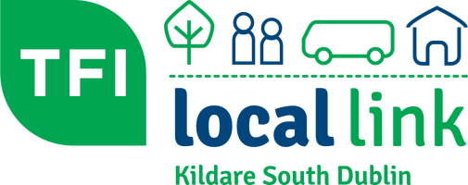
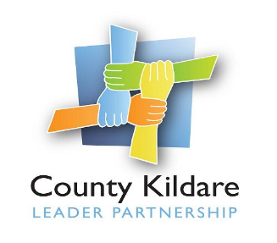

TFI Local Link Kildare South Dublin has this week announced details of a Social Transport Fund that is aimed at assisting individuals and groups with once off transport needs.
The fund has been established by TFI Local Link Kildare South Dublin as part of their commitment to reinvesting in local communities and meeting the social objective of the Company to contribute to social inclusion in the Kildare and South Dublin areas.
Announcing the fund this week Mr. Alan Kerry, Manager of TFI Local Link Kildare South Dublin stated the following “through the foresight of the Board of Directors, and their commitment to the charitable objectives of the organisation, the opportunity now exists for local community groups to engage in social activities for the remainder of 2023 where the cost of transport may have been a barrier to such activities. We look forward to turning the wheels again for passengers both old and new”
The fund has been boosted by a contribution of €10,000 matched funding by County Kildare LEADER Partnership under the Social Inclusion and Community Activation Programme (SICAP). Speaking on behalf of County Kildare LEADER Partnership Mr. Pat Leogue, General / Social Inclusion Manager welcomed the opportunity to collaborate with TFI Local Link Kildare South Dublin to assist in meeting transport needs for the target groups of SICAP. “We are delighted to be in a position to support this initiative which will encourage groups and individuals to avail of transport to engage in social activity and also to participate in education and training where appropriate” he said. “I hope that many groups in County Kildare use this opportunity to get out and about after COVID and that it will encourage community activity for the rest of this year” added Mr. Leogue.
The establishment of a social transport fund fills a gap in the region where many community and voluntary groups are unable to afford transport to engage in social activities and individuals, particularly in rural areas without a car, are unable to access services in the main urban centres.
The Social Inclusion Fund will provide a minimum of 25% and a maximum of 75% funding towards trips which must take place between July and December 2023.
The opening date for applications is 10th July 2023 and further details are available by emailing Eileen.Farrell@locallink.ie or phone 045 980383

