Think About Teaching, the Foundation Certificate
2021-22

Information Booklet

Maynooth University

… after completing the [foundation] course I feel like I will be just as good as anyone else on the [teacher education] course and feel confident that I will make a good teacher.
Carole (pseudonym)
Foundation Cert graduate

This information booklet provides an overview and some guidance on how to apply for The Think about Teaching Foundation Certificate at Maynooth University.

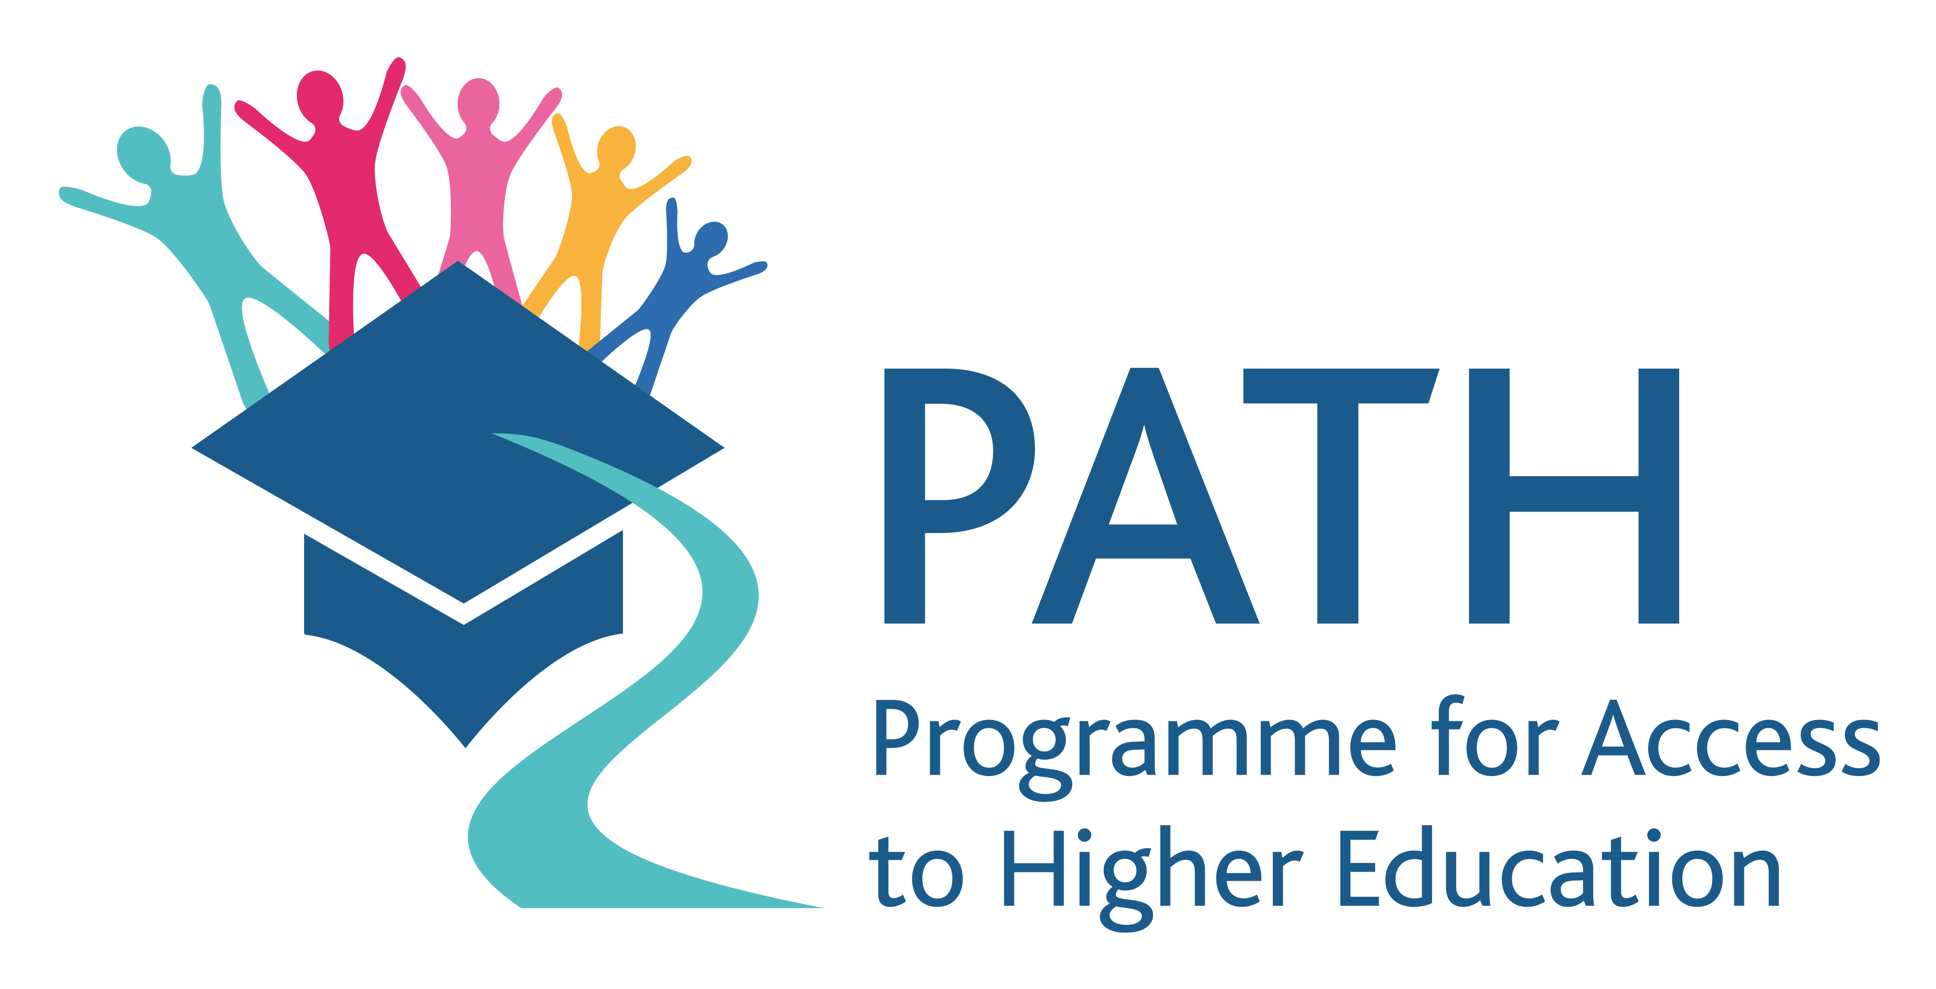

Contents

About the Think about Teaching Foundation Certificate 2
Pathways to teaching 2
Primary stream 2
Secondary Science and Maths stream 4
Bachelor of Arts stream 5
Frequently asked questions (FAQ) 7
How to apply 10

About the Think about Teaching Foundation Certificate
The Think About Teaching Foundation Certificate is a one year, Level 6 university preparation or access course for people who have an interest in teaching as a career path.
The course is run by Turn to Teaching staff from the Department of Adult and Community Education in partnership with the Froebel, Department of Primary and Early Childhood Education, the Department of Education (secondary), Maynooth Access Office (MAP), and the Admissions Office.
The School of Education is unique in Ireland in having four academic departments which cover teacher education and development from early childhood, through to primary, secondary and further education.
The purpose of the Foundation Certificate course is to support students to critically reflect on their own educational stories both individually and collectively as they work through educational and career pathways. The course also prepares students for the academic, social and cultural opportunities and challenges of university study.

Pathways to teaching
There are a number of pathways to becoming a teacher. Some graduates of the Think about Teaching Foundation Certificate will gain entry to Bachelor of Education (or ‘B.Ed’) programmes which lead, on successful completion, to a teacher qualification. Most graduates of the programme will progress to Bachelor of Arts degree (often called a ‘B.A’ ) which, on successful completion, will allow them to apply for any three of the postgraduate teaching qualification programmes (i.e., primary, secondary, further education).
You will be asked, on application for the Foundation Certificate, to rank your preference across the three streams in relation to your teaching aspirations:
- Primary stream
- Secondary Science and Maths stream
- Bachelor of Arts stream (leading to a number of teaching options)

Primary stream

If you are very focused on becoming a primary school teacher, you should choose ‘Primary’ stream as your first preference.
Students studying on this track of the programme will attend an Irish language competency module (Cumas na Gaeilge) that meets the requirement for entry into Initial Primary Teacher Education programmes such as the B.Ed (Primary) at Maynooth University.
Students will also participate in Maths and English competency classes, as well as a programme of supportive, academic development classes aimed at supporting students to integrate into the academic and social life within the university.
Students will develop practical knowledge and experience of teaching throughout the course and in partnership with school partners.
If you are applying for the primary track, you must have had some Irish language experience prior to application- this will be individually assessed upon application.
Possible progression routes on successful completion of the primary stream:
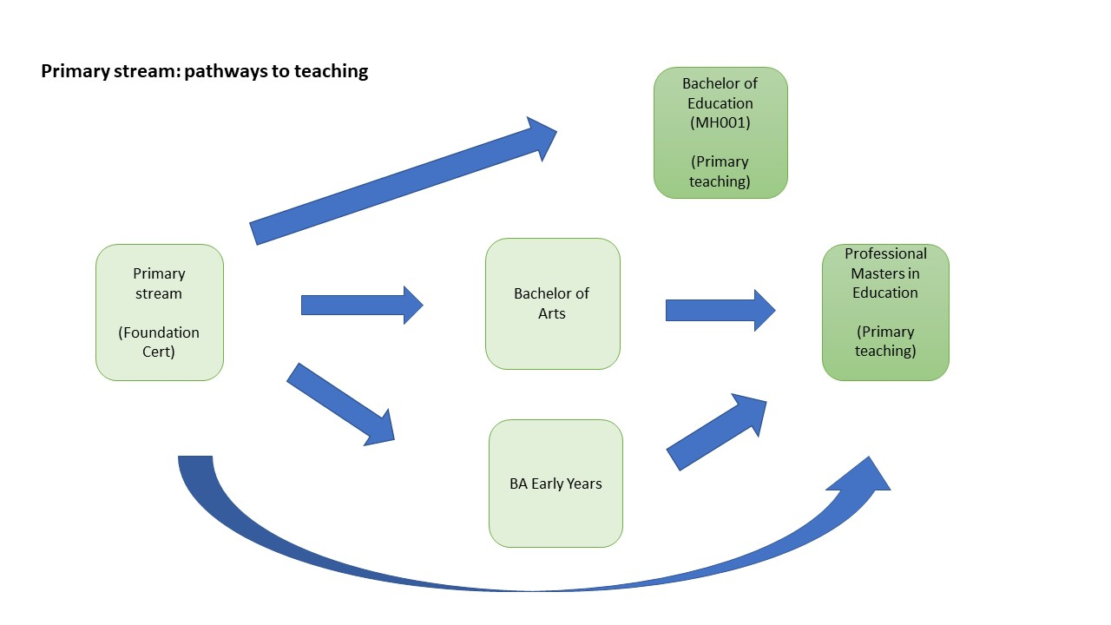
Students who successfully complete this stream of the Foundation Cert course can progress on to a number of degrees:
- MH001 Bachelor of Education (Primary Teaching) [numbers are limited and an exit interview at the end of the course will also be part of the progression if required]
- MH101 Bachelor of Arts Degree
- MH801 Bachelor of Arts in Early Childhood Teaching and Learning (part time)
- MH003 Bachelor of Arts in Early Childhood Teaching and Learning (full time)

A small number of students on the Foundation Cert may already have a degree. These students may progress to a Professional Masters of Education (Primary Teaching) [post-graduate].

Secondary Science and Maths stream

If you are interested in becoming a Maths or Science teacher in secondary schools, you should choose the ‘Secondary Science and Maths’ stream as your first preference on the application form.
The students who want to become secondary science/maths teachers will participate in modules that include: Fundamental Maths, Biology, Chemistry, Experimental Physics and Computer Science. These modules are run by Maynooth University's Foundation Cert in Science. Students will also attend a programme of supportive, academic development classes that aim to help students integrate to academic and social life within the university.
Students will develop practical knowledge and experience of teaching throughout the course and in partnership with school partners.
If you wish to undertake the Science and Maths Teaching stream you must have studied maths up to Junior Certificate level, or its equivalent.
Possible progression routes on successful completion of the Secondary Science and Maths track:

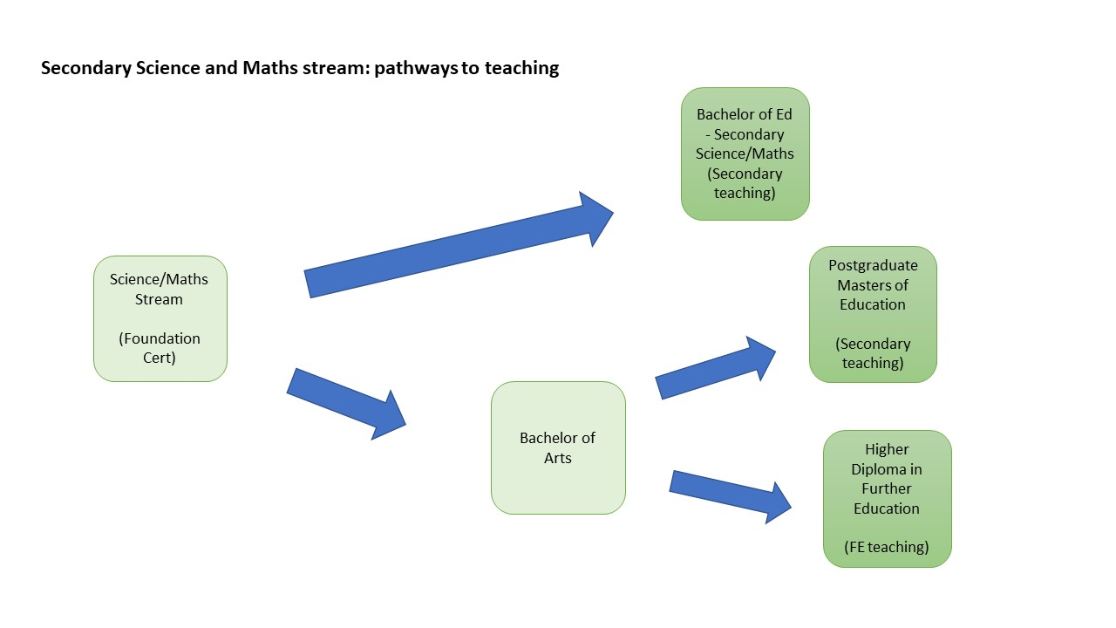
Students who successfully complete this stream of the Foundation Cert course can progress on to a number of degrees:
- MH212 BSc Mathematics and Computer Science (with Education): second level teacher qualification to teach Mathematics and Computer Science
- MH212 BSc Mathematics (with Education): second level teacher qualification to teach Mathematics and Applied Mathematics
- MH212 BSc Science (with Education): second level teacher qualification to teach two subjects from the following (biology, chemistry, physics or maths)
- Students also have the option to progress onto a Bachelor of Arts degree.

Bachelor of Arts stream

If you feel that you are interested in education and the possibility of teaching but want to keep your options open, then you should choose the ‘Bachelor of Arts’ stream on your application form.
This stream would also be appropriate for students who are interested in teaching in secondary, further education, primary or early childhood education.
Students will attend a programme of supportive, academic development classes which aim to help students embed within the university alongside arts and social science introductory courses.
Students will develop practical knowledge and experience of teaching throughout the course and in partnership with school partners.
Students on this track would, on successful completion of the Foundation Certificate, gain entry to an Arts (BA) degree. That degree, in itself, will not lead to teaching qualification but it is the first necessary step for application for a range of postgraduate teacher education programmes in primary, secondary and further education at Maynooth.
Students who have an interest in primary teaching can progress to the Bachelor of Arts (MH101) or the Bachelor of Arts in Early Childhood (MH801/MH003). However, students who are interested in applying for a postgraduate teacher education programme, must be conscious of the entry requirements – specifically in relation to Irish, Maths and English competencies.
Possible progression routes on successful completion of the Bachelor of Arts track:

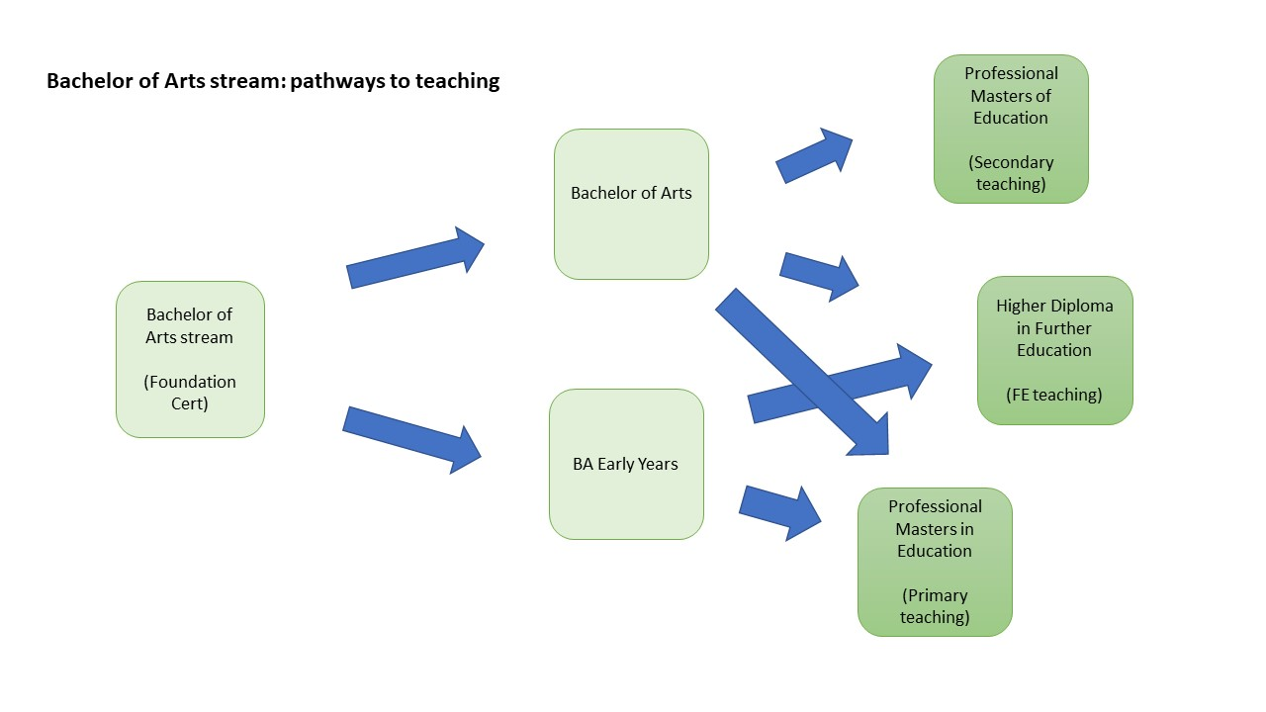
Students who successfully complete this stream of the Foundation Cert course can progress on to a number of degrees:
- MH101 Bachelor of Arts Degree
- MH801 Bachelor of Arts in Early Childhood Teaching and Learning (part time)
- MH003 Bachelor of Arts in Early Childhood Teaching and Learning (full time)

Frequently asked questions (FAQ)

Who is the Think About Teaching Foundation Certificate aimed at?
The Think About Teaching Foundation Cert is for young adults and/or mature students who have always wanted to become a teacher, but because of family, life, social and/or personal reasons were not able to pursue their dream through the usual education route.
In particular, the course is for students from particular groups that are currently under-represented in teaching, they include:
- Irish Travellers
- Students from ethnic minorities
- Students with a disability
- Migrants
- Lone parents
- Mature Students +23
- Students on a vocational or applied leaving cert track or youth reach
- Students progressing from Further Education courses
- Students who are, or were, in the care of the State
- Individuals who would be the first in their family to attend university
- Individuals who belong to groups that are under-represented in higher education based on their own occupation or employment status of their parents/guardians
- Individuals from DEIS schools with persistently low rates of progression to Higher Education
- Individuals coming from areas of deep or concentrated economic disadvantage

What are the entry requirements?
You must belong to one of the groups listed in the response to the previous question.
If you are applying for the primary stream, you must have had some Irish language experience prior to application- this will be individually assessed upon application.
If you wish to undertake the Secondary Science and Maths Teaching stream you must have studied maths up to Junior Certificate level, or its equivalent.
Although there are no formal entry requirements, you need to be aware that the programme is a Level 6 course (the Leaving Cert is Level 5).

What is the time commitment?
The Think About Teaching Foundation Certificate is a one-year full-time course and runs from September to May.
Classes are on all day Monday, Tuesday and Thursday starting at 10am and finishing by 5pm at the latest.
It is likely, based on previous years, that the Primary stream will also have classes on a Wednesday in Semester two (Feb-May).

Will I study on the university campus?
Yes, all your classes will be on campus in Maynooth.

Will I get a student card?
Yes. Like every other student at Maynooth University, you will get a student card and have access to the same range of services, supports, clubs and societies.

What does the course cost?
The course is free.

Am I eligible for SUSI?
The course is not currently covered by the SUSI scheme. However, we do work with students on a case-by-case basis around any financial issues and day to day costs.

What kind of supports are available?
Maynooth University has a wide range of supports to help all students make most of their time at college. We work very closely with the Maynooth Access Programme (MAP) who are committed to enhancing access to, and through, university for all members of Irish society. Some of their work helps in supporting applicants into university and a lot more in supporting students when they are at Maynooth. You can read more about the work and supports of MAP here: https://www.maynoothuniversity.ie/access-office/about-map
You can read more about the more general kind of supports that are offered for Maynooth students at the Student Services page: https://www.maynoothuniversity.ie/student-services

How do I apply?
Applications open on 01 Feb 2021 and close on 12 April 2021. The application form is online and available from the Turn to Teaching website: https://www.maynoothuniversity.ie/turntoteaching
You will also need to get to referees to complete a reference form that you can download and pass on to them. They must return that to us by the 12 April 2021 too.

What is the selection process?
We review all applications and then write and tell you if you have been shortlisted for an interview. If you are called to interview, we will explore your motivation to become a teacher. We anticipate that interviews will take place in May 2021. We will inform all interviewees of the outcome of the interview process in July.

How do I find out more about the Foundation Course?
For further information, please visit our website:
https://www.maynoothuniversity.ie/turntoteaching

You can also contact the team by email on turn2teaching@mu.ie or by phone on 01 474 7556

How to apply

To apply for the Think About Teaching Foundation Certificate (2021-22) you must complete, in full, the online application form found on the Turn to Teaching website: https://www.maynoothuniversity.ie/turntoteaching
You will be unable to save any work that you have done on the form so you will need to complete it in one sitting. As part of the online application you will be asked a number of open questions which you may want to work through in a word document first before copying into the form.
In particular, you will be asked to write a personal statement of no more than 500 words which you would be well-advised to work on offline before copying into the application form.
The closing date for applications for the Think About Teaching Foundation Cert (2021-22) is 12 April 2021.

Referees
We will also need to receive two references in support of your application.
Please download the referee form from the Turn to Teaching website https://www.maynoothuniversity.ie/turntoteaching and send it to two of your referees. There is guidance on the form for them to return it to us directly by the 12 April 2021. It is applicants’ responsibility to ensure that two references are submitted to us by email by the closing date.

