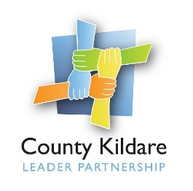
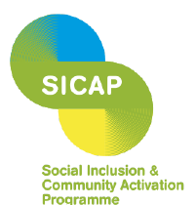

County Kildare LEADER Partnership
Is seeking a
Project Worker (DARA Project)

The DARA Project is a Drug Rehabilitation Community Employment Scheme in two locations - Athy and Kildare Town - where participants receive a range of supports to progress into further education, training, and employment.
The Project is now expanding its services to establish a stabilization programme in Kildare Town for individuals who are committed to becoming drug free.
With the assistance of funding under the Social Inclusion and Community Activation Programme (SICAP) we are seeking a Project Worker. This role will involve key working with service users, advocating on behalf of the service user, managing resources, and ensuring the programme meets its goals and objectives.
The successful candidate will have:
- a minimum of two years’ experience in key working with service users within a substance abuse or mental health setting. Experience in rehabilitation or stabilization programmes is highly desirable.
- a strong background in addiction recovery work, an understanding of addiction recovery, experience in substance abuse treatment, or a related field, and possess excellent organizational and leadership skills.
- excellent communication and interpersonal skills, good IT and report writing skills, an ability to work on own initiative and within a team environment.
Salary: €36,696 per annum.
A copy of the job description is available at www.countykildarelp.ie or by email: liz@countykildarelp.ie
Application by letter and C.V. should be submitted by email to liz@countykildarelp.ie
Closing date for receipt of applications: Wednesday 2nd October 2024 at 5 p.m. County Kildare LEADER Partnership is an Equal Opportunities Employer.
