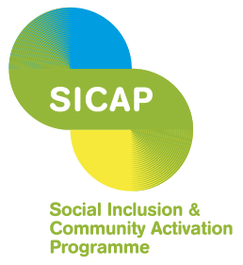

County Kildare LEADER Partnership
Is seeking a

Community Engagement Worker
County Kildare LEADER Partnership is the Programme Implementer for the Social Inclusion and Community Activation Programme (SICAP) in County Kildare.
We are recruiting a Community Engagement Worker to engage with individuals and groups in locations across County Kildare. The Worker will establish initial contact with residents and help to build the capacity of disadvantaged communities.
The successful candidate will have a relevant third level qualification. Prior experience would be desirable but is not essential and recently qualified graduates are encouraged to apply as on-the-job training will be provided.
The successful candidate will have excellent communication and interpersonal skills, very good IT and organisational skills and an ability of working on their own initiative. A good understanding of the issues in disadvantaged communities is desirable.
Remuneration will include a Company Defined Contribution pension scheme and access to support for further education and training.
A full driving license and own transport is also essential.
A full job description and person specification is available at www.countykildarelp.ie or by email to olivia@countykildarelp.ie.
Application by cover letter and C.V. should be submitted to olivia@countykildarelp.ie
County Kildare LEADER Partnership is an Equal Opportunities Employer
Closing date for receipt of applications: Friday 2nd May 2025.
Interviews will be held week beginning, Monday 12th May 2025.


