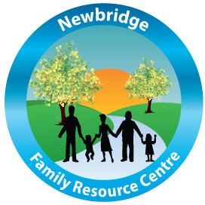
Newbridge Family Resource Centre, Newbridge, Co. Kildare

Position: Special Needs Assistant (SNA) – Specified Contract
Newbridge Family Resource Centre are currently recruiting for the position of SNA under the Access and Inclusion Model (AIM) specified contract (15 hours) for our community based Early Years Pre-school, which caters for children aged 2.4 years to 5 years.
The ideal candidate should possess the following:
- A minimum QQI Level 6 qualification or working towards a recognised Early Years accreditation.
- An understanding and knowledge of planning for the appropriate support and activities required for children with additional needs in collaboration with the Access and Inclusion Model (AIM) specified contract.
- A strong teamwork ethic and the ability to work on own initiative.
- A knowledge of Childcare (Amended Pre-school) Regulations (2016).
- An understanding of Child Protection Regulations (Always Children First)
- Possess good communication, oral and written skills.
- An ability to build strong professional relationships with team members, parents and external agencies.
- Experience of working within an Early Years’ service is desirable but not essential.
Application process:
Please email CV and cover letter to paula@newbridgefrc.ie or by post to Paula Mullally, Early Years Manager, Newbridge Family Resource Centre, Newbridge, Co. Kildare.
Closing date for applications: Wednesday 14th October 2020
Interviews will be held Monday October 19th, 2020
Shortlisting will apply.

