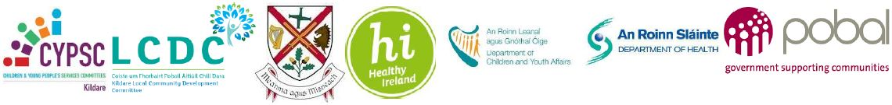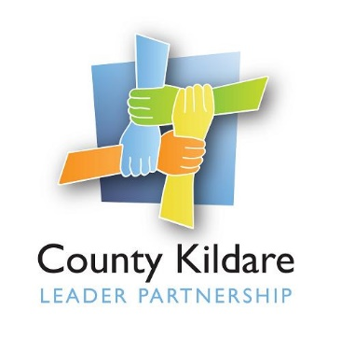
County Kildare LEADER Partnership
Is seeking a
Healthy Ireland Programme Coordinator
County Kildare LEADER Partnership is the host organisation for the employment of the Healthy Ireland Co-ordinator in Kildare. The Healthy Ireland programme in Kildare is overseen by Kildare Local Community Development Committee (LCDC) with Kildare County Council as financial partner and contract holder.
Funding for Heathy Ireland Round 3 was secured following an application by Kildare Local Community Development Committee (LCDC) and Kildare Children and Young People’s Services Committee (CYPSC). The overall purpose of the funding is to support innovative, cross-sectoral, evidence-based projects and initiatives that support the implementation of key national policies in areas such as obesity, smoking, alcohol, physical activity, and sexual health.
The successful candidate will have a relevant third level qualification, for example health promotion, education, community development, public health or social care. S/he will have excellent communication skills, including the use of social media, good negotiating skills, excellent administration, report writing and data management / IT skills. Financial administration and budgeting skills will also be required. Previous relevant work experience in community development, social sciences or related fields is essential as well as an understanding of working with disadvantaged groups and collaboration with a wide range of stakeholders.
S/he will have a full driving license and their own transport.
A fixed term contract of employment will be offered to the successful candidate. The contract will be part time (28 hours per week) and the salary will be within a scale of €35,977- €39,166 (pro rata) based on experience.
A panel maybe formed, should further vacancies become available. Secondment arrangements may be considered.
Applicants are invited to submit a comprehensive Curriculum Vitae accompanied by a cover letter outlining the skills and experiences of the applicant to fit with the post (no more than 700 words) by email only marked Confidential Kildare Healthy Ireland Co-ordinator to: caroline@countykildarelp.ie .
Please note that late, postal or hand delivered applications will not be accepted. A copy of the job description is available at www.countykildarelp.ie or by email: info@countykildarelp.ie
Closing date for receipt of applications: Monday 14th June 2021 at 5pm. Interviews will be held week commencing 21st June 2021.

County Kildare LEADER Partnership is an Equal Opportunities Employer.

