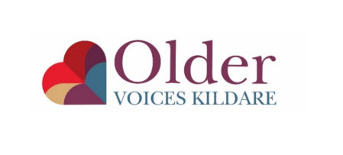
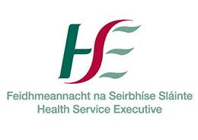
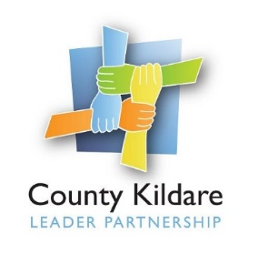

County Kildare LEADER Partnership
Is seeking an
Older Voices Kildare Project Coordinator
The Older Voices Kildare project is a social inclusion initiative for older people in County Kildare managed by County Kildare LEADER Partnership and funded by HSE.
The Coordinator will lead the development of Older Voices Kildare and the services it provides to older people in County Kildare, working closely with a voluntary steering group and other key stakeholders including funders, a pool of volunteers and older people.
The successful candidate will have a relevant third level qualification, for example health promotion, community development, public health or social care. The successful applicant will have excellent communication and interpersonal skills and an interest in working with older people who are most at risk of social exclusion. They will also have very good administration, report writing and IT skills. Previous relevant work experience of coordinating services for older people is desirable as well as experience of engaging with a wide range of stakeholders including funders and local service providers. Experience of working with a pool of volunteers is also desirable.
A fixed term contract of employment to 31st December 2023 will be offered to the successful candidate. The contract will be full time and the salary will be within a scale of €39,166 - €43,909 based on experience. The successful applicant will have a full driving license and their own transport.
Application by CV and a cover letter outlining the skills and experiences of the applicant should be submitted by email only marked Confidential Older Voice Kildare Co-ordinator to: caroline@countykildarelp.ie .
A copy of the job description is available at www.countykildarelp.ie or by email: info@countykildarelp.ie

Closing date for receipt of applications: Monday 13th September at 5pm. Interviews will be held week commencing 20th September 2021.

County Kildare LEADER Partnership is an Equal Opportunities Employer.

