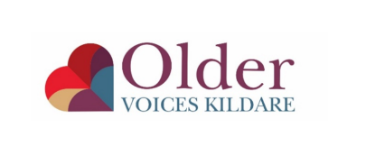
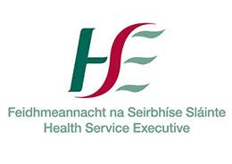
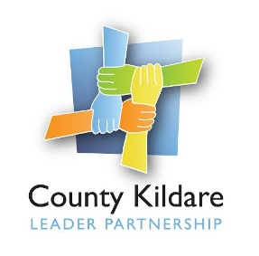

Job description

Coordinator, Older Voices Kildare

Background

The Older Voices Kildare (OVK) project is a social inclusion initiative managed by County Kildare LEADER Partnership and funded by HSE which has the following aims:
- To assist and facilitate people to explore their own ageing and to challenge the myths and stereotyping that leads to ageism.
- To provide information on physical, psychological, and social aspects of growing older – all of which increase self-confidence and improve mental health
- To explore the issues and barriers that older men experience in participation on community programmes and to develop initiatives to address this
- To facilitate a befriending service to address high levels of loneliness and social isolation in the County.
- To develop specific strategies to include more marginalised categories of older people, older LGBT’s, Travellers, people with intellectual or physical disability, and older people in residential or long terms care settings, and people with dementia and their carers.

Role and Responsibilities
The Coordinator will lead the development of Older Voices Kildare and the services it
provides to older people in County Kildare, working closely with a voluntary steering group
and other key stakeholders including funders, a pool of volunteers and older people.
The Coordinator will:

- Play a strong leadership role within the organisation to ensure the ethos and values of OVK are maintained and developed.
- Support the engagement of older people in their community and the development of older persons groups in line with the principles of community development
- Work creatively and collaboratively to develop programmes and initiatives to support the inclusion of older people in their communities and wider society.
- Develop and promote strong interagency relationships with other services and agencies.
- Be responsible for the internal organisation and day to day management of the project
- Work with the Steering Group to implement appropriate policies and procedures approved by the Board of County Kildare LEADER Partnership to ensure best practice and accountability.
- Identify funding sources, make applications on behalf of the Project, and liaise with the relevant funding agencies
- Present monthly work / progress reports to the Steering group and Board of County Kildare LEADER Partnership.
- Oversee the financial and risk management of the Project in liaison with the CKLP Financial Controller.
- Support and supervise OVK staff and volunteers
- Identify and source specific further education and training opportunities for staff and volunteers
- Carry out any additional tasks that may be deemed necessary for the effective running of the Project.

Specifically the role includes:
Project Management
Develop and implement the OVK strategy and workplan.
Raise the profile of the project and promote programmes
Develop and implement monitoring and evaluation systems.

Staffing
Lead a team – staff and volunteers - to include supervision and support.
Engage and contribute as a member of the Coordination Staff Group with the line managers of all programmes managed by CKLP.

Interagency Collaboration
Develop and maintain close and effective working relationships with organisations working with the OVK target group.
Provide regular progress reports to the programme’s Steering Group
Provide reports and updates to the HSE and any other funders as required from time to time.

Policy development
Represent the experience of OVK at local, regional and national levels
Contribute to the strategic policies of County Kildare LEADER Partnership in relation to health and wellbeing
Keep up-to-date on national and international developments in relation to the target group

Financial Oversight
Oversee the day-to-day financial management of the project
Identify funding opportunities and make applications
Prepare an annual budget detailing all aspects of the organisation’s activities and present at the beginning of the financial year
Liaise with the Financial Controller of County Kildare LEADER Partnership to ensure that budgets and financial reports are available to the Steering Group and the Board of Directors.

Reporting Relationship:
The Co-ordinator will report to the Health and Wellbeing Manager.

Hours of Work:
The post is full time 35-hour week, excluding lunch. Hours of work are normal office hours e.g., 9 a.m. to 5 p.m. but flexibility of working hours for evening and weekend work is required for this position and time off in lieu will apply.

Salary: The salary scale will be €39,166 - €43,909.

Person Specification

Skills and Attributes | Essential | Desirable
Training and Qualifications | A recognised third level qualification in health promotion, community development, public health or social care | Training or experience in working with older persons.  Experience of developing inclusive and engaging experiences which respond to the interests and needs of the diverse older adult population
Experience | Previous experience in a similar leadership role.  Have experience of delivering programmes within public health, community development or health promotion  Have demonstrated capacity to achieve results through cross-sectoral working with multiple stakeholders  Experience in accessing funding and managing budgets | Ability to mobilise, inspire and motivate.  Ability to think strategically, shape strategic direction and to take and execute decisions
Knowledge and Skills | Knowledge and understanding of the evidence base related to health promotion  Strong communication skills and the ability to manage multiple stakeholders and project priorities  A clear knowledge and understanding of challenges facing older persons.  An in-depth understanding of social and health challenges and complex needs of target group  Skilled in building relationships with both internal and external stakeholders and in working collaboratively  Innovative approach with the ability to identify and develop new and fresh ways to expand the programme that will further the Project’s aims and objectives.  Critical thinking and analytical skills  Excellent report writing skills and analysis  Financially literate | Knowledge of the supports and services available in Kildare.  Knowledge of the particular challenges experienced by the older adult population  Capacity to develop resilience, and build the skills needed to achieve the best quality of life for older persons.
Communication / Interpersonal Skills | Strong interpersonal skills and ability to build positive relationships with target group, agencies etc  Be dynamic, engaging, motivating, encouraging, inspiring and personable.  Proactive and highly organised, with strong time management, planning skills and attention to detail  Excellent IT skills, proficiency with MS Office Suite and other managerial IT systems.
Other requirements | Own transport  Full clean driving licence

