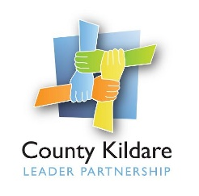
County Kildare LEADER Partnership
Is seeking a
Traveller Community Development Worker (Part Time)
County Kildare LEADER Partnership is the Local Development Company for County Kildare and is responsible for the management of a range of local, rural and community development programmes on behalf of Government Departments and state agencies.
We are seeking a Traveller Community Development Worker who will will engage with the Traveller Community in County Kildare on an outreach basis to facilitate community development initiatives and also support Travellers on an individual basis to take up Community Employment Scheme places allocated to CKLP. This is a part time (21 hours per week) position initially with the potential to develop.
The successful candidate will have professional experience in community development or a related discipline. They will have an understanding and respect for Traveller culture and also have an ability to facilitate and engage with individuals and groups with a strong commitment to community development principles and practice.
They will have excellent communication and interpersonal skills, very good IT and organisational skills as well as a proven ability of working on their own initiative.
Previous experience of working with the Traveller community is essential and a good knowledge of County Kildare is desirable. Applications from the Traveller community will be welcomed.
A full driving licence and own transport is also essential.
A twelve month fixed term contract will be offered to the successful candidate. Salary: €32,687 per annum pro rata.
For full Job Description please email info@countykildarelp.ie
Application by letter and C.V. should be submitted to caroline@countykildarelp.ie
County Kildare LEADER Partnership is an Equal Opportunities Employer and welcomes applications from members of the Traveller Community.
Closing date for receipt of applications: Tuesday 12th October 2021 at 5pm.
Interviews will take place week commencing 18th October 2021.

