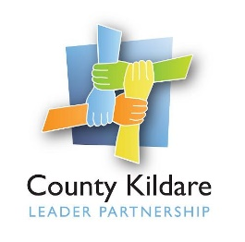
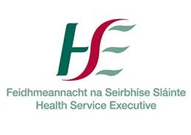

County Kildare LEADER Partnership
Is seeking a
Social Prescribing Link Worker
County Kildare LEADER Partnership is the Local Development Company for County Kildare and is responsible for the management of a range of local, rural and community development programmes on behalf of Government Departments and state agencies. County Kildare LEADER Partnership (CKLP) has been contracted by HSE to act as host organisation for the employment of a Social Prescribing Link Worker as part of the Sláintecare Healthy Communities Initiative. This Initiative is focused on the implementation of an enhanced Health and Wellbeing Programme within areas that have the greatest levels of disadvantage and highest proportion of young families to deliver evidence informed services to improve local population health and wellbeing outcomes. In County Kildare the Sláintecare Healthy Communities Initiative will be initially focused on the Athy Municipal Area.
Social Prescribing Link Worker: The Social Prescribing Link Worker will report to the CKLP Health and Wellbeing Manager and will be responsible for working with individuals on a one-to-one basis to improve health and wellbeing as well as working in partnership with health professionals and the community and voluntary sector. Social prescribing involves referral from a healthcare professional and agreed referral to a local community activity or service following a consultation with the referred person.
The successful candidate will be educated to a third level qualification in community development, health promotion or a related field, have a minimum of three years’ experience in community development, health promotion, or related field, have experience of supporting people in a 1:1 or group capacity and have experience building relationships across a variety of organisations. They will have knowledge and experience of reducing health inequalities, excellent communication, interpersonal, analytical, and problem-solving skills a as well as a commitment to a quality service.
They will also have a full driving licence and their own transport.
A fixed term contract to 31st December 2023 will be offered to the successful candidate. The salary scale is HSE Grade V commencing at €43,628 and will be commensurate with skills and experience.
A copy of the job description is available at www.countykildarelp.ie or by email: info@countykildarelp.ie
Application by letter and C.V. should be submitted by email to caroline@countykildarelp.ie

Closing date for receipt of applications: Monday 22nd November 2021 at 4 p.m. Interviews will be held week commencing 29th November 2021

County Kildare LEADER Partnership is an Equal Opportunities Employer.

