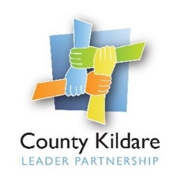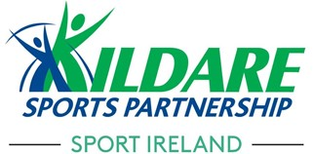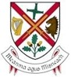

Kildare Sports Partnership
Is seeking a
Sports Hub Coordinator

County Kildare LEADER Partnership is the host organisation for the employment of a Sports Hub Coordinator on behalf of Kildare Sports Partnership and Kildare County Council.
The Sports Hub Coordinator will develop and grow the Community Sports and Physical Activity Hub projects in Athy and Monasterevin which are mainly focussed, but not exclusively, on water-based activity on the River Barrow and Grand Canal. The Coordinator will also be responsible for implementing a comprehensive plan to promote, attract and develop sustainable usage of the hubs.
The ideal candidate will have a water sports and/or participation background, with knowledge of sport in Ireland and at least three years relevant experience.
They will also have a full driving licence and their own transport.
An initial fixed term contract to 31st December 2023 will be offered to the successful candidate. The salary will be offered commensurate with skills and experience on the Grade 4 Local Authority scale.
A copy of the job description and application form is available at www.countykildarelp.ie or by email: info@countykildarelp.ie
Application by application form only should be submitted by email to caroline@countykildarelp.ie

Closing date: Applications must be received no later than 5pm on Friday, February 18th, 2022.

County Kildare LEADER Partnership is an Equal Opportunities Employer.

