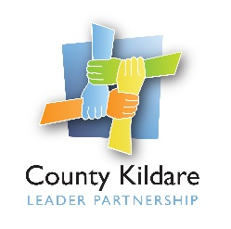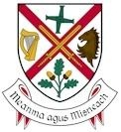
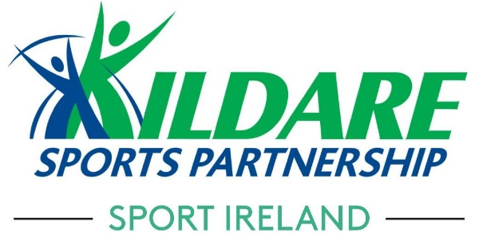

SPORTS HUB CO-ORDINATOR
Fixed Term Contract

Kildare Sports Partnership is seeking a Sports Hub Co-ordinator. This post will be to develop and grow the Community Sports and Physical Activity Hub projects in Athy and Monasterevin which are mainly focussed, but not exclusively, on water based activity on the River Barrow and Grand Canal and to implement a comprehensive plan to promote, attract and develop sustainable usage of the hubs.
The successful candidate will be employed by County Kildare LEADER Partnership on behalf of Kildare Sports Partnership and Kildare County Council under a hosting agreement
The ideal candidate will have a water sports and/or participation background, with knowledge of sport in Ireland and at least 3 years relevant experience.
Contract Type: Fixed Term
Salary: Depending on Experience
Interested applicants should complete the Community Sports Hub Coordinator application form along with a cover letter and submit as detailed below.

Applications should be emailed to: caroline@countykildarelp.ie
Closing date: Applications must be received no later than 5pm on Friday, February 18th 2022.

Job Description
General
The Sports Hub Co-ordinator will be employed by County Kildare LEADER Partnership. They will report to the Sports Co-ordinator, Kildare Sports Partnership and work with the relevant organisations and individuals to develop, co-ordinate and implement a comprehensive plan to promote water sport in the county and attract and develop sustainable usage of the Community Sports and Physical Activity Hubs on the River Barrow and Grand Canal at Athy and Monasterevin.
The successful candidate will also work closely with Kildare County Council, local water-based clubs, other sport and physical activity groups, schools and community based organisations to promote the facility/amenity as a venue for sustainable community sport and physical activity.

Overall Purpose of Position:
To assist Kildare Sports Partnership in achieving its core objectives of:
- Developing partnership and co-ordination between the relevant local statutory and voluntary bodies and maximising their involvement in the development of water sports in the county
- Supporting the existing clubs in their club development plans through governance, club structure and programmes
- Thinking strategically in the development of water-based clubs and facilities in the area
- Delivering water sport programmes to key target communities as agreed by Kildare Sports Partnership including; schools, youth groups, clubs and organisations
- Increasing participation and the opportunities for participation in water sports on the River Barrow and Grand Canal
- Helping to maximise the sports and recreation potential of the River Barrow, Grand Canal and Barrow Blueway by promoting existing events and developing new water sport events
- Promoting the Community Sports Hub as a venue for sustainable physical activity

Specific Responsibilities:
Reporting to Kildare Sports Partnership Sports Co-ordinator on a day to day basis, the Sports Hub Co-ordinator will have responsibility for the implementation of current and future development programmes of Kildare Sports Partnership including -
Education:
- Planning, organising and implementing education & skills courses
- Assist in the development of training courses as required
- Providing education, up-skilling and identification of volunteers through various programmes and Club structures
Development:
- Organise and implement appropriate training and education activity for Schools, Adult groups, socially excluded groups, youth groups and people with disabilities
- Organise and implement Summer / Easter camp programme
- Deliver programmes to key target communities
- Assist in hosting and promoting events
Facility Development:
- Assist stakeholders in facility grant applications
- Support and advise on the continued development of Water Sports Centre in Athy & Monasterevin
- Make maximum use of the River Barrow, Grand Canal and Barrow Blueway.

Management Processes:
- Adhere to all management processes as directed by the Coordinator of Kildare Sports Partnership and / or persons nominated by them
- An agreed annual work programme must be developed, agreed and implemented
- Supply reports on dates outlined by the Sports Partnership Co-ordinator
- Strictly adhere to procedures outlined by the Sports Partnership Co-ordinator in relation to any financial matters
- A quarterly report will be submitted to the Sports Partnership Co-ordinator

Promotion of Water Based Sport:
- Work in cooperation with all stakeholders to promote sport and physical activity and develop and grow the Community Sports Hubs on the River Barrow and Grand Canal.
- Identify and assist local community initiatives which may benefit the development of the Community Sports Hubs
- Support the development of communications promoting the Community Sports Hub
Administration:
- Administrate all courses and activities
- Support the promotion of the Community Sports Hubs
The post is a two-year contract, subject to satisfactory completion of a 3 month probationary period. The Sports Hub Co-ordinator will work 35 hours per week. Some flexibility of hours will be required for evening and/or weekend work to accommodate the service needs, for which time off in lieu can be taken. Travelling expenses will be reimbursed where appropriate.

Interested applicants should forward a completed Application Form to caroline@countykildarelp.ie Closing date for receipt of Application: - 5pm on Friday, February 18th 2022.

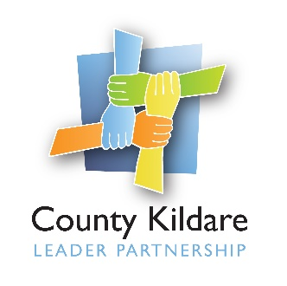
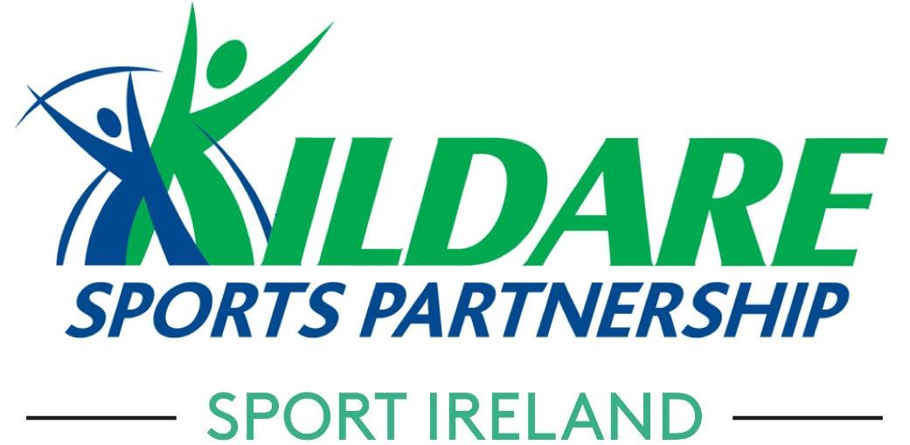
Sports Hub Co-ordinator
Personal Specification
Health
Candidates shall be in a state of health which would indicate a reasonable prospect of ability to render regular and efficient service.
Qualifications & Experience
- Relevant degree in Sports Development, Leisure Management, Health & Fitness & Leisure Studies or equivalent is desirable
- Three years experience working in the sports development / community sector
- An understanding of the community and voluntary sector and sports and recreation environment and of motivating those sectors with lower participation characteristics to become involved
- Experience in the delivery of water-based sports programmes and activities is essential
Skills & Competencies
Management and Change
- Ability to understand and implement change and demonstrate flexibility and openness to change within the Community and Voluntary Sector
- Ability to develop and maintain positive, productive and beneficial working relationships

Delivering Results/Communicating Effectively
- Ability to plan work and allocate staff and other resources effectively
- Ability to implement high quality service and customer care standards
- Have excellent communications, presentation and facilitation skills
- Understand the different methods of communications and use of same

Performance Management and Teamwork
- Ability to supervise a team or work area to achieve corporate objectives
- Have a constructive, positive and progressive attitude to working as part of a team
- Have a self-motivated approach to work
- Have a strong team ethic of co-operation and mutual support
- Ability to create partnerships with individuals, groups, clubs, relevant agencies and the wider community

Personal Effectiveness
- Ability to take the initiative and be proactive when the opportunity to make a contribution arises
- Ability to manage time and workload effectively
- Ability to maintain a positive and constructive and enthusiastic attitude to their role
- Have an ability to problem solve

Knowledge, Experience and Skills
- Demonstrate the knowledge and understanding of the structure and functions of the Local Sports Partnership network
- Demonstrate the knowledge of current issues for physical activity levels.
- Understanding of the role of the Community Sports Hub Coordinator within a Local Sports Partnership
- Have relevant “on-the-job” experience and evidence of a similar role, particularly in the area of water sport development
- Have strong administrative and organisational skills
- Ability to monitor and evaluate work and write reports.
- Ability to co-ordinate and facilitate events
- Ability to think strategically in the development of clubs and facilities
- Ability to deliver a range of water-based programmes and activities
- Ability to produce and access information efficiently and accurately
- Have knowledge and experience of operating ICT systems
- Ability to prepare, monitor and manage budgets

Transport
- A full clean driving license and use of personal transport for work is required.
- Willingness and ability to travel

