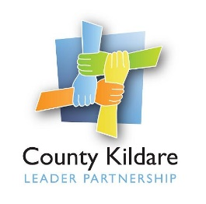
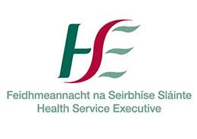
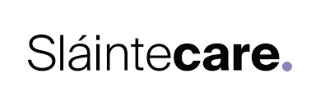

County Kildare LEADER Partnership
Is seeking a
Healthy Food Made Easy Coordinator
County Kildare LEADER Partnership is the Local Development Company for County Kildare and is responsible for the management of a range of local, rural and community development programmes on behalf of Government Departments and state agencies. County Kildare LEADER Partnership has been contracted by HSE to act as host organisation for the employment of a Healthy Food Made Easy Coordinator as part of the Sláintecare Healthy Communities Initiative. This Initiative is focused on the implementation of an enhanced Health and Wellbeing Programme within areas that have the greatest levels of disadvantage and highest proportion of young families to deliver evidence informed services to improve local population health and wellbeing outcomes. In County Kildare the Sláintecare Healthy Communities Initiative will be initially focused on the Athy Municipal Area.
Healthy Food Made Easy Coordinator : The Healthy Food Made Easy Coordinator will report to the Health and Wellbeing Manager and will be responsible will be responsible for the delivery of the 6-week Healthy Food Made Easy (HFME) programme funded by the HSE Slaintecare Healthy Communities Initiative. It is an evidenced based programme which has been running for 20 years engaging communities living with food poverty.
The successful candidate will be educated to a third level qualification in Social, Community, Health, Nutrition or a related field, have a minimum of three years’ experience in a community development, healthcare, training or related field, have experience of supporting people in a 1:1 or group capacity and have experience building relationships across a variety of organisations. They will have knowledge and experience of reducing health inequalities and an understanding of the wider determinants of health, excellent communication, interpersonal, analytical, and problem-solving skills a as well as a commitment to a quality service.
They will also have a full driving licence and their own transport.
A fixed term contract to 31st December 2023 will be offered to the successful candidate. The salary scale is HSE Grade V commencing at €43,628 and will be commensurate with skills and experience.
A copy of the job description is available at www.countykildarelp.ie or by email: info@countykildarelp.ie
Application by Application Form ONLY, should be submitted by email to caroline@countykildarelp.ie

Closing date for receipt of applications: Friday June 24^{th,} 2022 at 5pm. Interviews will be held week commencing 4th July 2022

County Kildare LEADER Partnership is an Equal Opportunities Employer.

