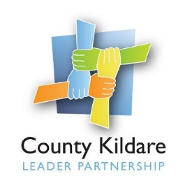

County Kildare LEADER Partnership
Is seeking a
Manager for Kildare Traveller Action CLG

The Board of Kildare Traveller Action CLG (KTA) is seeking to recruit a Manager to develop Kildare Traveller Action Ltd into a vibrant Traveller Community Development organisation. The Manager will lead the organisation in supporting the equal participation of Travellers in the social, cultural, and economic life of County Kildare ensuring high levels of Traveller engagement and Traveller representation on the Board of Kildare Traveller Action with reference to the company’s Strategic Plan

County Kildare LEADER Partnership will act as host employer for this position through funding under the Social Inclusion and Community Activation Programme (SICAP) with co funding from Kildare County Council and other sources.

The successful candidate will hold a relevant third level qualification in Community Development or related field, have a minimum of three years’ hands on experience of managing a community development organisation and have experience of working with the Traveller Community.
They will have excellent communication and organisational skills, proven organisational and time management skills, experience in providing leadership including support and supervision of staff, good personal motivation and drive to promote and deliver the ethos of Kildare Traveller Action, excellent interpersonal and IT skills, a proven ability of working on their own initiative and have a full driving licence and own transport.
A three-year fixed term contract will be offered to the successful candidate. Salary: €48,884. The remuneration package will also include a company pension and support for further education and training
Applications by Curriculum Vitae (CV) only to caroline@countykildarelp.ie .
Closing date for receipt of completed application forms on Tuesday 26th July 2022 at 5.00pm.

Late applications will not be accepted - Canvassing will disqualify.

A copy of the job description and person specification is available at www.countykildarelp.ie or by email: caroline@countykildarelp.ie

County Kildare LEADER Partnership is an Equal Opportunities Employer.

