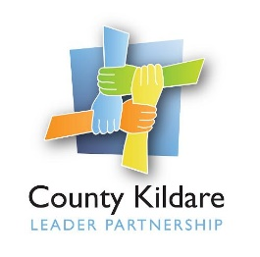
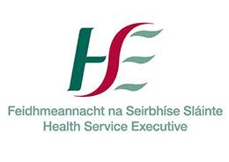
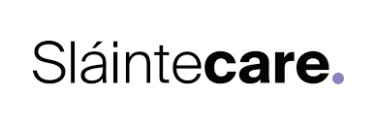

County Kildare LEADER Partnership
Is seeking a
Community Food and Nutrition Worker
County Kildare LEADER Partnership is the Local Development Company for County Kildare and is responsible for the management of a range of local, rural and community development programmes on behalf of Government Departments and state agencies. County Kildare LEADER Partnership has been contracted by HSE to act as host organisation for the employment of a Community Food and Nutrition Worker as part of the Sláintecare Healthy Communities Initiative. This Initiative is focused on the implementation of an enhanced Health and Wellbeing Programme within areas that have the greatest levels of disadvantage and highest proportion of young families to deliver evidence informed services to improve health and wellbeing outcomes. In County Kildare the Sláintecare Healthy Communities Initiative will be initially focused on the Athy Municipal Area.
Community Food and Nutrition Worker : The Community Food and Nutrition Worker will report to the Health and Wellbeing Manager and will be responsible will be responsible for the provision of capacity for the Sláintecare Healthy Communities to improve community health and wellbeing in the designated Healthy Community areas by addressing the issues of poor diet and food poverty. This is not a clinical role. The post-holder will not provide clinical, therapeutic, nutritional interventions or care.
The successful candidate will be educated to a third level qualification in the area of Nutrition and Health, have a minimum of three years’ experience in health promotion or health behaviour change, and have experience of building relationships across a variety of organisations. They will have knowledge and experience of reducing health inequalities and an understanding of the wider determinants of health, excellent communication and interpersonal skills a as well as a commitment to a quality service.
They will also have a full driving licence and their own transport.
An initial one-year fixed term contract will be offered to the successful candidate. The salary scale is HSE Grade VI commencing at €€49,041.

A copy of the job description is available at www.countykildarelp.ie or by email: info@countykildarelp.ie
Application by Application Form ONLY, should be submitted by email to caroline@countykildarelp.ie

Closing date for receipt of applications: Monday September 5th 2022 at 5pm. Interviews will be held week commencing 19th September 2022

County Kildare LEADER Partnership is an Equal Opportunities Employer.

